BN, June 2019

Customer: Voestapine

Business case:

Currently customer is manually calculating the PPM with information from GSS, which is manual process that odes add any value.

Solution:

Add two tabs to existing ARC 4920 to account for such calculations.

Each tab will need to have the following maintenance items:

Location Selection Date Range Setup a goal [First tab]The PPM

*** External calculation should be as follows: [ Total number of external rejects/Total number shipped]*1,000,000 * * need to account for actual part numbers shipped and exclude non-inventory parts [we can do this by Product line] [Second tab]

***Internal calculation should be as follows: Total number of internal rejects/Total number shipped]*1,000,000 Notes: You will see one location graph at a time. Sample of the graphs and calculations attached on this call.

**Menu item: Quality System > View > Quality Dashboard Ex/In PPM 5549**

**External**

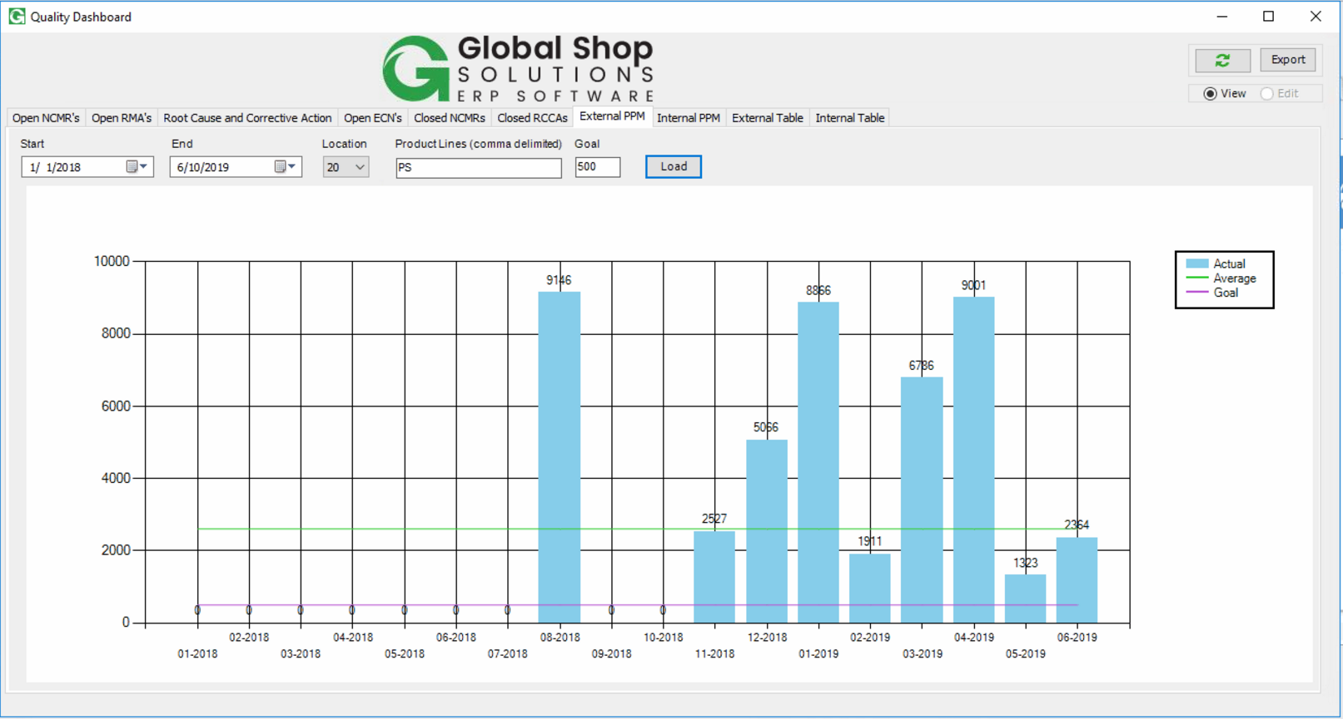

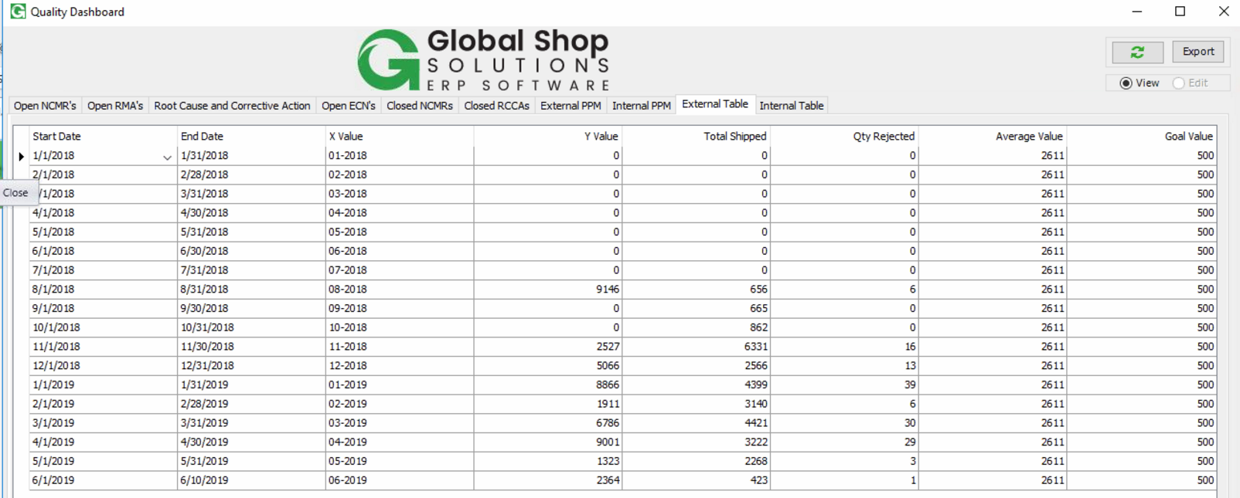

**Internal**

